Ticketing Management System
Client User Guide
Ticketing Management System — Akshay Software Technologies Pvt. Ltd.
Audience: Client Users (End Users raising support requests)
Document Version: v5.0.0.0 | Last Updated: July 2026
Table of Contents
1 | Introduction
2 | System Requirements
3 | Getting Started – First-Time Login
4 | Logging In & Logging Out
5 | Understanding the Dashboard
6 | Creating a Support Ticket
7 | Uploading Attachments
8 | My Tickets – Viewing, Searching & Filtering
9 | Ticket Details & Communication
10 | Ticket Statuses Explained
11 | Tracking Ticket Progress
12 | Responding to Consultant Queries
13 | Submitting Feedback & Closing Tickets
14 | Notifications & Email Alerts
15 | Managing Your Profile
16 | Changing Your Password
17 | Theme & Appearance Settings
18 | Security Best Practices
19 | Frequently Asked Questions (FAQs)
20 | Troubleshooting Guide
21 | Support & Contact Information
22 | Document Revision History

1. Getting Started – First-Time Login
The first-time login process is designed to securely activate your account and ensure that only authorized users can access the Ticket Management System (TMS).
When your account is created by the Super Administrator, you will receive a Welcome Email containing the following information:
- Portal URL
- Registered Email Address
- Temporary Password
- Basic login instructions

Prerequisites
Before logging in for the first time, ensure that:
- You have received your Welcome Email.
- You have a stable internet connection.
- You are using a supported web browser:
  - Google Chrome (Recommended)
  - Microsoft Edge
  - Mozilla Firefox

Step 1 – Open the Ticket Management System
Launch your preferred web browser and navigate to the Portal URL provided in your Welcome Email.
The Login page will be displayed.
Figure 1 – Login Page
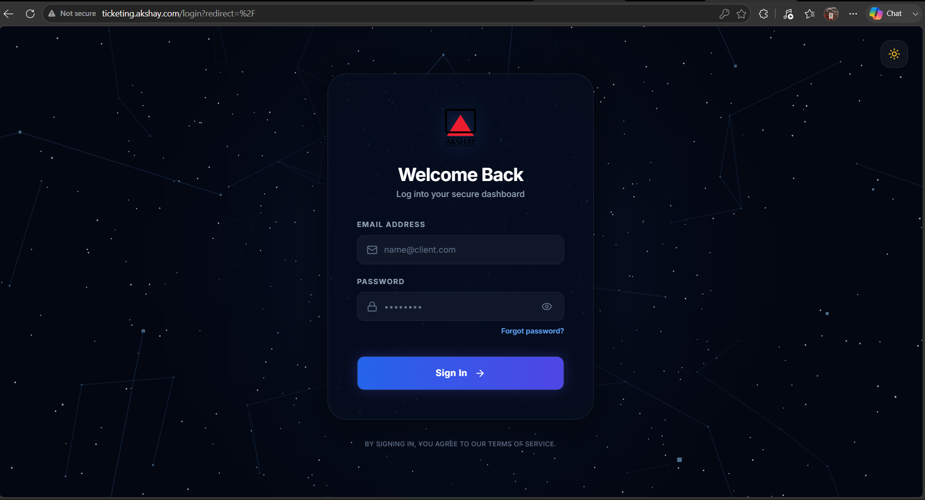
Step 2 – Enter Your Login Credentials
Enter the following information:
- Email Address – The email address registered with your account.
- Temporary Password – The password provided in the Welcome Email.
Verify that both values are entered correctly.

Step 3 – Sign In
Click the Login button.
The system will validate your credentials and initiate the first-time account activation process.

Step 4 – Change Your Password
For security purposes, the system requires all first-time users to create a new password before accessing the application.
The Change Password screen will automatically appear.
Figure 2 – First-Time Password Change
(Insert Password Change Screenshot Here)

Step 5 – Create a Secure Password
Enter your new password and confirm it.
It is recommended that your password contains:
- Minimum 8 characters
- At least one uppercase letter (A–Z)
- At least one lowercase letter (a–z)
- At least one numeric digit (0–9)
- At least one special character (e.g., @, #, $, %, &)
Choose a password that is unique and not used for any other applications.

Step 6 – Save Your Password
Click Update Password.
If the password satisfies the security requirements, the system will:
- Save your new password securely.
- Activate your account.
- Redirect you to the Client Dashboard.
Your account is now ready for use.

Password Security Best Practices
- Never share your password with anyone.
- Do not reuse passwords from other systems.
- Change your password periodically.
- Log out after completing your work, especially when using a shared computer.
- Avoid saving passwords in public or shared browsers.
Important: System administrators will never ask for your password through email, phone calls, or instant messaging. If you receive such a request, report it immediately to your system administrator.

Expected Outcome
After successfully completing the first-time login process, you will be able to:
- Access the Ticket Management System.
- View your personalized dashboard.
- Create and manage support tickets.
- Track ticket progress.
- Receive notifications and updates.
- Securely access all features permitted for your role.
2. Logging In & Logging Out
This section explains how to securely log in to the Ticket Management System (TMS), recover your password if necessary, and safely log out of the application.

2.1 Regular Login
Follow these steps to access the Ticket Management System:
Step 1 – Open the Portal
Launch your preferred web browser and navigate to the Ticket Management System portal URL.
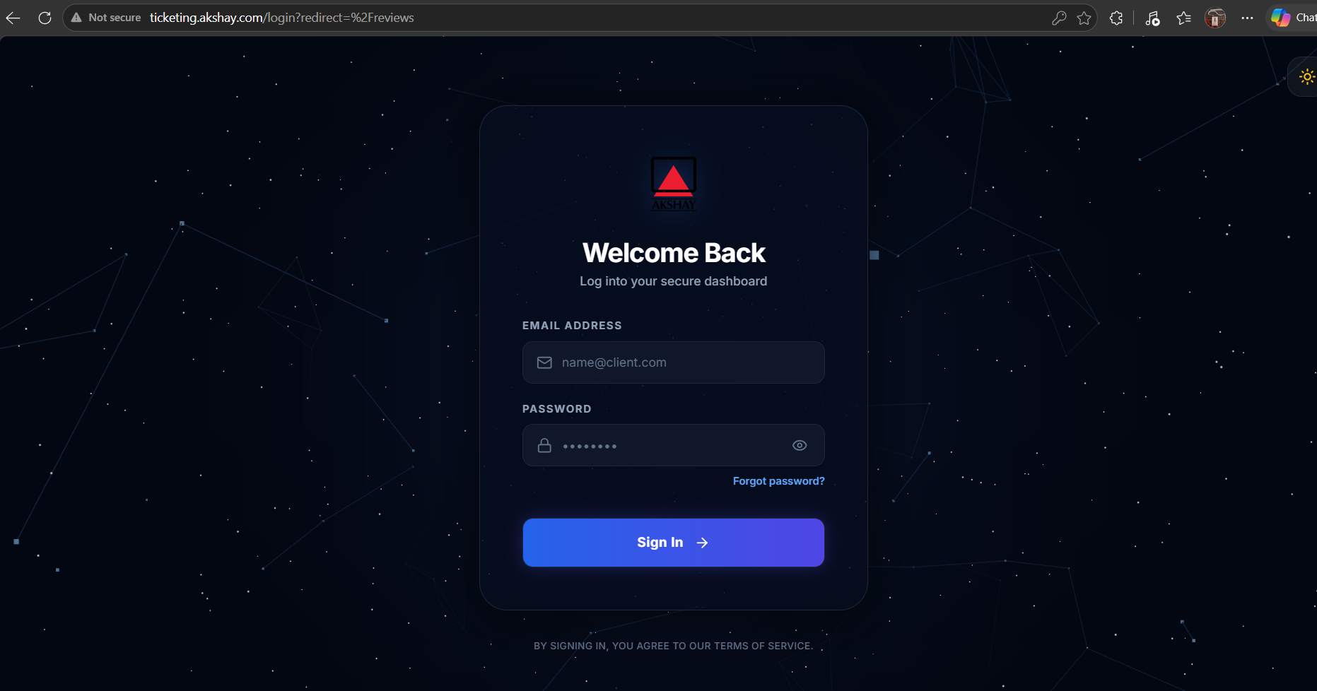
Step 2 – Enter Your Credentials
Provide the following information:
- Registered Email Address
- Password
Ensure both fields are entered correctly.

Step 3 – Sign In
Click the Login button.
If the credentials are valid, the system will authenticate your account and redirect you to your dashboard.
Your personalized settings, including your preferred theme and dashboard preferences, will be loaded automatically.

2.2 Login Security
For security purposes, the system automatically protects your account by:
- Validating user credentials before granting access.
- Allowing access only to authorized users.
- Loading role-specific dashboards based on your assigned permissions.
- Maintaining a secure authenticated session during your login.
If invalid credentials are entered, an appropriate error message will be displayed, allowing you to try again.

2.3 Forgot Password
If you forget your password, you can reset it using the password recovery feature.
Step 1
On the Login page, click Forgot Password?

Step 2
Enter your registered email address.

Step 3
Click Send Reset Link.
The system will send a secure password reset email to your registered email address.

Step 4
Open the email and click the password reset link.
The reset link remains valid for 24 hours.

Step 5
Create a new password that meets the organization's password policy.
After updating your password, return to the Login page and sign in using your new credentials.
Note: If you do not receive the password reset email within a few minutes, check your Spam, Junk, or Promotions folder before contacting your system administrator.

2.4 Logging Out
To protect your account and maintain system security, always log out after completing your work.
Step 1
Click your Profile Avatar located in the upper-right corner of the application.
Figure 4 – User Profile Menu
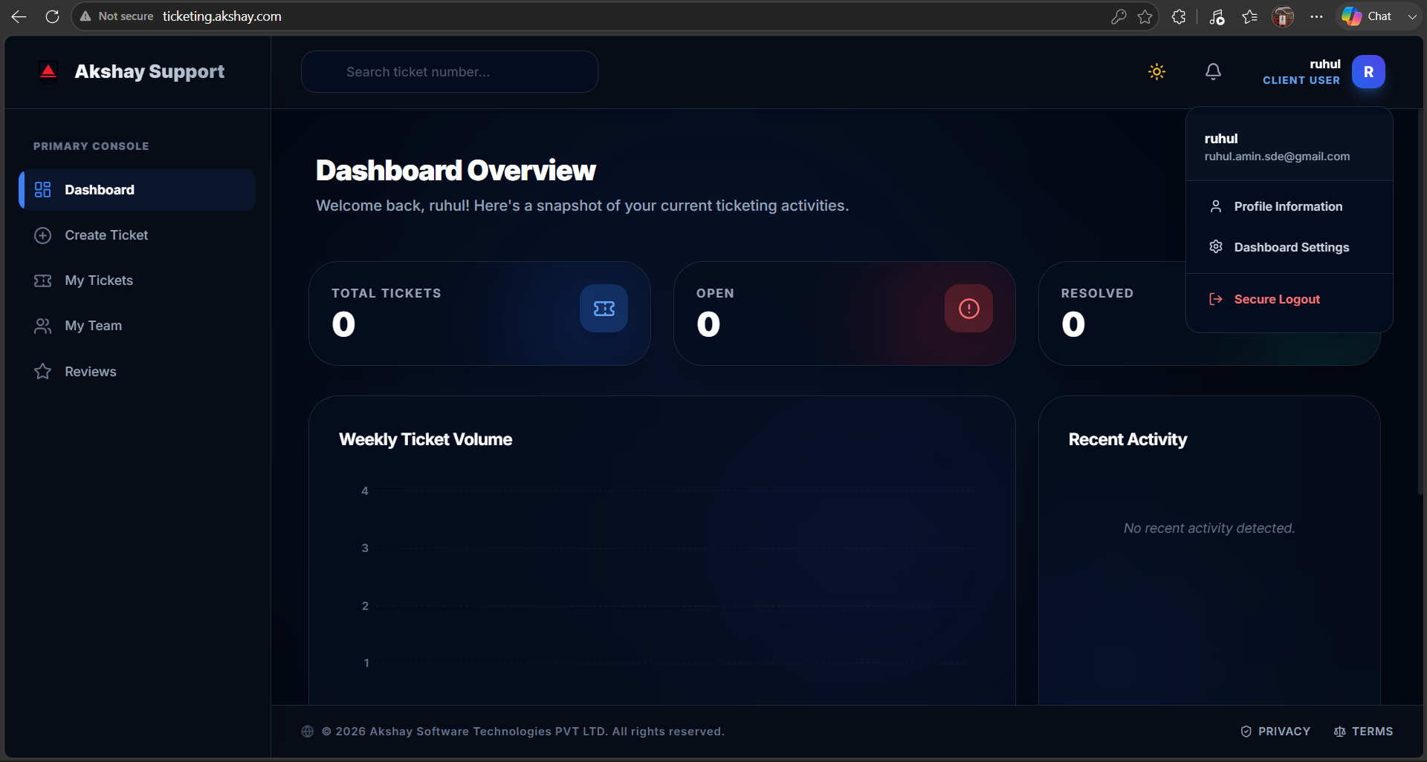
Step 2
Select Logout from the profile menu.

Step 3
The system will immediately terminate your authenticated session and redirect you to the Login page.

2.5 Security Best Practices
To help keep your account secure:
- Never share your login credentials.
- Always use a strong password.
- Do not save passwords on shared or public computers.
- Log out before leaving your workstation.
- Immediately report any suspicious login activity to your system administrator.

Expected Outcome
After following the procedures in this section, you will be able to:
- Securely log in to the Ticket Management System.
- Recover your password if forgotten.
- Maintain a secure authenticated session.
- Safely log out of the application when your work is complete.

3. Dashboard Overview
After successfully logging in, you will be redirected to the Client Dashboard, which serves as the central workspace for managing your support requests and monitoring ticket activities.
The dashboard provides real-time visibility into your support requests, ticket status, notifications, and important announcements, allowing you to quickly access the information most relevant to your role.
Figure 5 – Client Dashboard
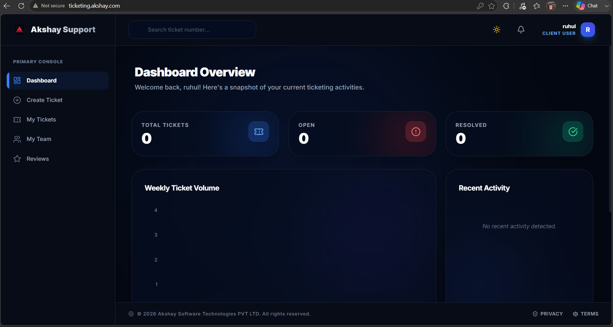
3.1 Dashboard Layout
The Client Dashboard is organized into several functional sections designed to provide quick access to frequently used features.
The dashboard includes:
- Navigation Sidebar
- KPI Summary Cards
- Notice Board
- Recent Tickets
- Profile & User Menu

3.2 Navigation Sidebar
The left navigation panel provides quick access to the primary features available to Client Users.
Menu | Description
Dashboard | Displays an overview of ticket statistics, notifications, and recent activities.
Create Ticket | Create a new support request by providing the required information and attachments.
My Tickets | View, search, filter, and track all tickets submitted by your account.
Profile | View and update your personal information, change your password, and manage preferences.

3.3 KPI Summary Cards
At the top of the dashboard, Key Performance Indicator (KPI) cards provide an instant overview of your ticket activity.
KPI Card | Description
Total Raised | Total number of support tickets submitted by your account.
Open | Tickets that have been created but are yet to be assigned or processed.
Assigned | Tickets currently assigned to a consultant for resolution.
In Progress | Tickets actively being worked on by the assigned consultant.
On Hold | Tickets temporarily paused due to pending information, dependencies, or customer confirmation.
Resolved | Tickets for which a solution has been provided and are awaiting closure or confirmation.
Closed | Tickets that have been successfully completed and officially closed.
These cards are updated automatically as ticket statuses change.

3.4 Notice Board
The Notice Board displays important announcements published by the Super Administrator.
Typical announcements include:
- Planned maintenance activities
- System upgrades
- Scheduled downtime
- New feature announcements
- Organization-wide policy updates
- Important service notifications
Tip: Before creating a new ticket, review the Notice Board to determine whether your issue has already been identified or announced.

3.5 Recent Tickets
The Recent Tickets section displays your latest support requests in a tabular format.
Each record provides a quick summary of the ticket.
Field | Description
Ticket ID | Unique identifier assigned to the support request.
Subject | Brief summary of the reported issue.
Department | Department responsible for handling the ticket.
Category | Ticket classification selected during creation.
Priority | Business priority (Critical, High, Medium, or Low).
Status | Current stage of the ticket lifecycle.
Assigned Consultant | Consultant responsible for resolving the ticket.
Created Date | Date and time when the ticket was submitted.
Last Updated | Most recent activity recorded for the ticket.
Selecting any ticket opens the Ticket Details page, where you can review the complete conversation, attachments, work history, and resolution progress.

3.6 Notifications
The dashboard also displays notifications related to your tickets.
Examples include:
- Ticket successfully created
- Ticket assigned to a consultant
- Consultant comments or requests additional information
- Ticket status changes
- Resolution updates
- Ticket closure notifications
- System announcements
Notifications help you stay informed without manually checking every ticket.

3.7 Profile & User Menu
The user menu is located in the upper-right corner of the dashboard.
From this menu, you can:
- View your profile
- Update account information
- Change your password
- Switch application themes (if enabled)
- Log out securely

Dashboard Benefits
The Client Dashboard enables users to:
- Monitor all support requests from one location.
- View real-time ticket status updates.
- Receive important system notifications.
- Quickly access frequently used features.
- Track consultant assignments and ticket progress.
- Stay informed about system announcements and maintenance activities.

Expected Outcome
After understanding the Dashboard, you will be able to:
- Navigate the Ticket Management System efficiently.
- Monitor ticket activity in real time.
- View support request summaries and performance indicators.
- Access your tickets and profile quickly.
- Stay informed about system updates and important announcements.

4. Creating a Support Ticket
Creating a support ticket is the primary function of the Ticket Management System (TMS). Providing complete and accurate information ensures that your request is automatically routed to the appropriate consultant and resolved as efficiently as possible.

4.1 Create a New Ticket
You can create a new ticket from either:
- Create Ticket in the left navigation menu.
- + New Ticket button on the Dashboard.
Figure 6 – Create Ticket Form
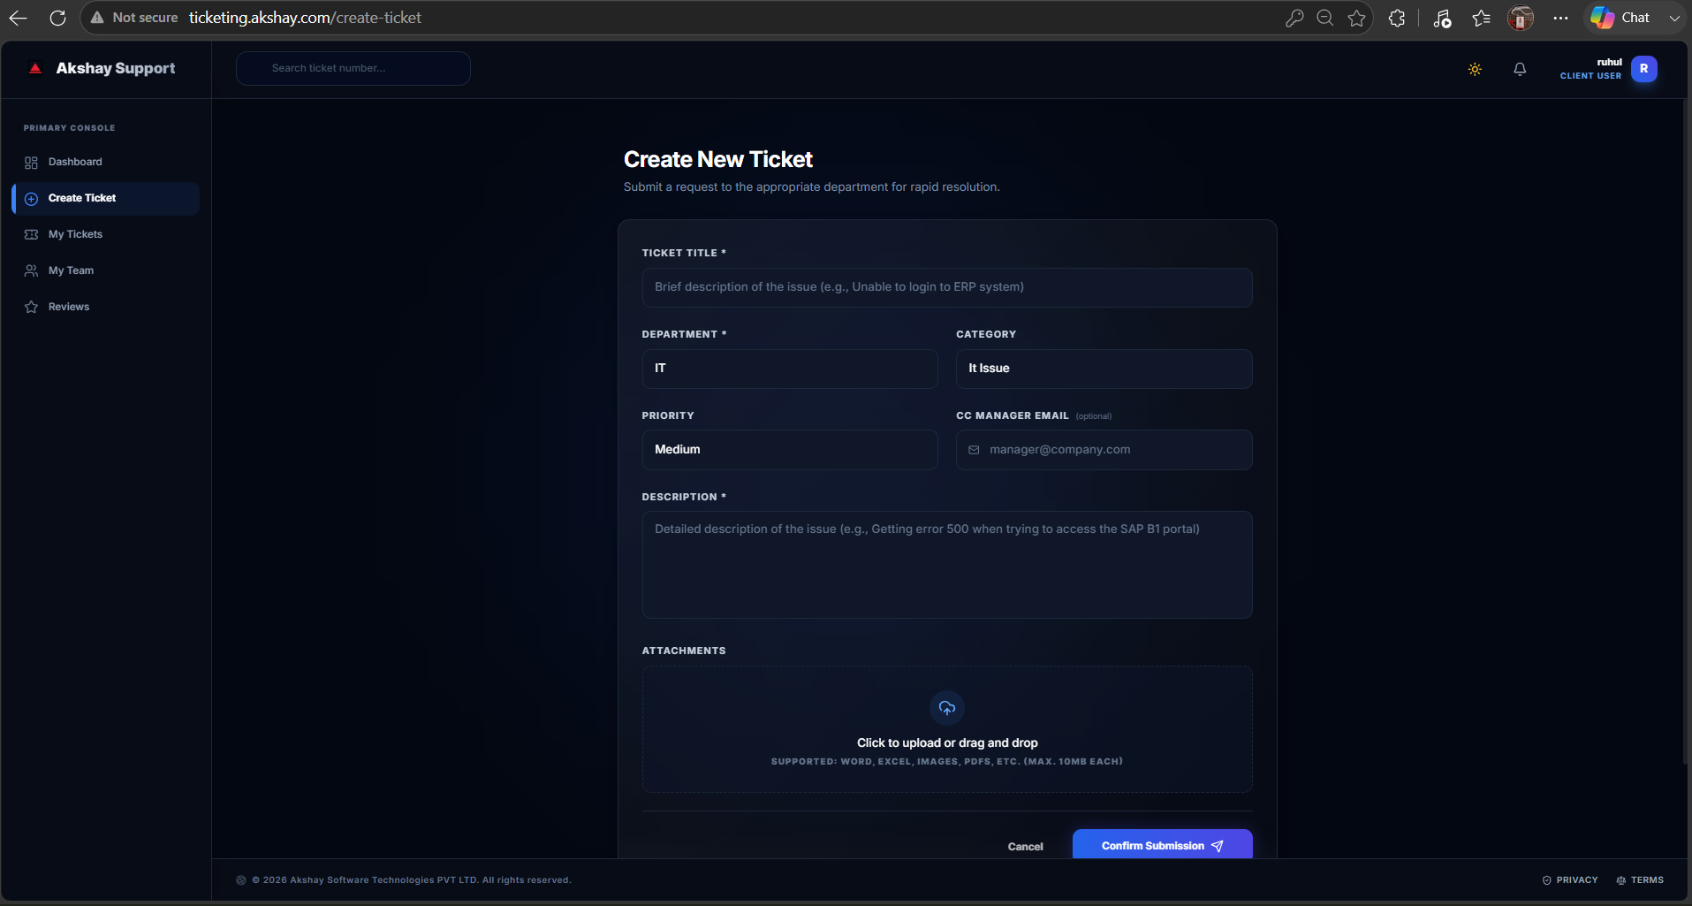
4.2 Step-by-Step Procedure
Step 1 – Open the Ticket Form
Navigate to Create Ticket from the sidebar or click + New Ticket from the dashboard.
The Create Ticket page will open.

Step 2 – Complete the Ticket Form
Fill in all mandatory fields before submitting the ticket.
The following sections explain each field in detail.

4.3 Ticket Information
Ticket Title (Required)
Provide a short and meaningful summary of your issue.
Good Example | Avoid
SAP B1 – Invoice Printing Failure After Update | SAP Problem
Unable to Generate Sales Report | Need Help
User Login Failure After Password Reset | Urgent Issue
A descriptive title helps consultants quickly understand the issue and improves automatic ticket routing.

Department (Required)
Select the department responsible for resolving your issue.
Department | Purpose
Software Development | Application bugs, new features, enhancements, APIs, web applications, integrations, and custom development requests.
ERP | SAP Business One, CREST ERP, reports, transactions, finance, inventory, production, purchasing, sales, and ERP-related technical issues.
Finance | Billing, invoices, payments, accounting, finance approvals, taxation, and financial process-related requests.
General Support | General assistance, account-related requests, or issues not covered by the above departments.

Category (Required)
After selecting the department, the system displays the categories available for that department.
Examples include:
- Login Issues
- Report Issues
- Performance Issues
- New Feature Request
- Bug Report
- API Issue
- Integration Issue
- Database Issue
- Finance Query
- Invoice Issue
Selecting the appropriate category helps ensure accurate routing and faster resolution.

ERP Incident Type (Displayed When Applicable)
If ERP Incident Types are configured for your organization, select the option that best describes your issue.
Examples include:
- Functional
- Technical
- Authorization
- Performance
- Database
- Integration
- Add-On
- Master Data
- Transaction Processing
- Reporting
This field enables intelligent consultant assignment based on ERP expertise.

Priority (Required)
Choose the priority according to the business impact.
Priority | Recommended Usage | Target Response
Critical | Complete business interruption or production outage | Immediate
High | Major functionality unavailable with significant business impact | Same Business Day
Medium | Partial functionality affected with an available workaround | Next Business Day
Low | Minor issue, information request, or cosmetic enhancement | As Scheduled
Use Critical only for production issues that prevent normal business operations.

CC Email (Optional)
You may specify one or more email addresses to receive ticket updates.
Examples:
- Department Manager
- Team Lead
- Project Coordinator
- Business Owner
All configured recipients will receive ticket notifications throughout the ticket lifecycle.

Description (Required)
Provide complete information about the issue.
Include the following whenever possible:
- Detailed description of the issue
- Steps performed before the issue occurred
- Exact error message
- Expected behavior
- Actual behavior
- Number of affected users
- Business impact
- Date and time the issue started
- Any recent system changes
- Temporary workaround (if available)
The more information you provide, the faster the consultant can diagnose and resolve the issue.

Attachments (Recommended)
Attach supporting files whenever possible.
Examples include:
- Screenshots
- Error Messages
- PDF Documents
- Excel Files
- Log Files
- Reports
- Configuration Files
Supported file types include:
- PNG
- JPG
- PDF
- XLSX
- DOCX
- TXT
- CSV
- LOG
Attachments help consultants understand and reproduce the reported issue more efficiently.

4.4 Review Before Submission
Before submitting your ticket, verify that:
- All required fields are completed.
- The correct department is selected.
- The correct category is selected.
- Priority reflects the actual business impact.
- The description contains sufficient information.
- Relevant attachments have been uploaded.

4.5 Submit the Ticket
Click Submit Ticket.
The system will:
- Validate the entered information.
- Generate a unique Ticket ID.
- Save the ticket.
- Apply routing rules (if configured).
- Assign the ticket automatically or place it in the assignment queue.
- Record the activity in the audit history.

4.6 Ticket Submission Confirmation
After successful submission:
- A confirmation message is displayed.
- A unique Ticket ID is generated.
- The ticket appears in My Tickets.
- Email notifications are sent automatically.
- The assigned consultant receives a notification.
- Additional configured recipients (CC emails) are notified.
Example:
Ticket Created Successfully
Ticket ID: TKT-2026-000143
Status: Open
Assigned To:
Automatically Assigned / Pending Assignment

4.7 What Happens Next?
After your ticket is submitted, the Ticket Management System automatically performs the following actions:
- Generates a unique Ticket ID.
- Records the ticket creation time.
- Applies routing and assignment rules.
- Notifies the assigned consultant.
- Sends email notifications to the requester and configured CC recipients.
- Starts SLA tracking.
- Records all future updates in the ticket history and audit log.

Tips for Faster Resolution
- Use a clear and descriptive ticket title.
- Select the correct department and category.
- Choose the appropriate priority level.
- Include complete business and technical details.
- Attach screenshots or supporting documents.
- Mention any temporary workaround already attempted.
- Avoid creating duplicate tickets for the same issue.

Expected Outcome
After completing this section, you will be able to:
- Create accurate and complete support tickets.
- Provide sufficient information for faster issue resolution.
- Upload supporting documents and screenshots.
- Understand how tickets are automatically routed.
- Track your request using the generated Ticket ID throughout its lifecycle.
5. My Tickets – Viewing, Searching & Filtering
The My Tickets page provides a centralized view of all support requests created under your account. From this page, you can monitor ticket progress, search for specific requests, apply filters, and access detailed ticket information.
To open this page, select My Tickets from the left navigation menu.
Figure 7 – My Tickets
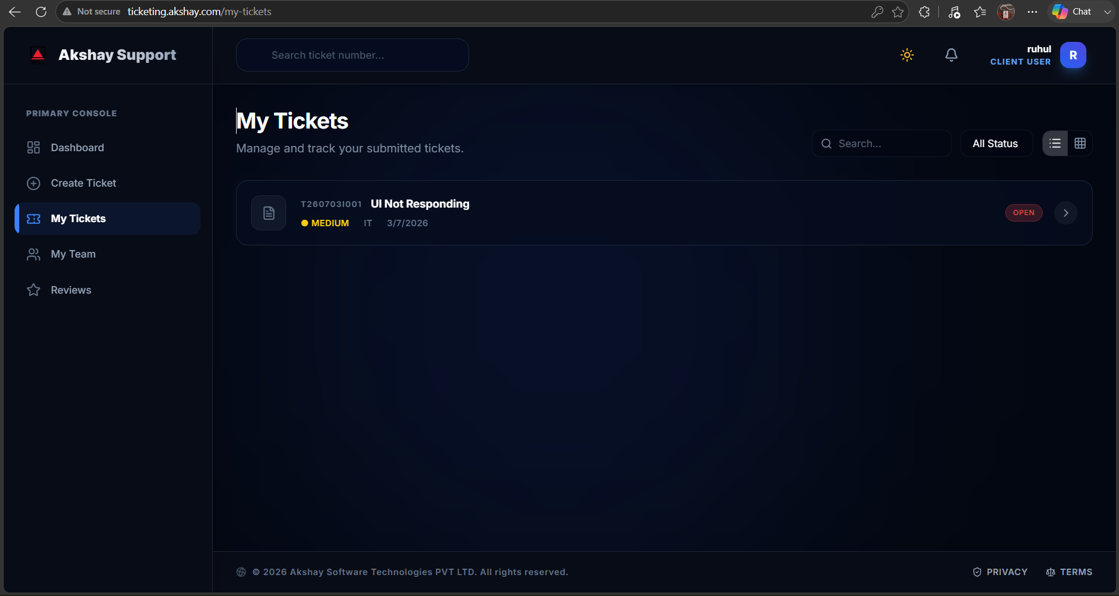
5.1 Ticket List Overview
The Ticket List displays all tickets submitted by you in a structured table.
Each ticket provides a summary of its current status and assigned consultant.

5.2 Searching for Tickets
Use the Search box to quickly locate a ticket.
You can search using:
- Ticket ID
- Ticket Title
- Description keywords
- Department
- Category
The list updates automatically as you type.

5.3 Filtering Tickets
Multiple filters are available to help locate tickets quickly.
Filter | Description
Search | Search using Ticket ID, title, or keywords.
Status | Filter by Open, Assigned, In Progress, On Hold, Resolved, or Closed.
Priority | Filter by Critical, High, Medium, or Low priority.
Department | Display tickets belonging to a specific department.
Category | Filter tickets by category.
Assigned Consultant | View tickets assigned to a particular consultant (when visible to clients).
Date Range | Filter tickets created within a selected date range.
Filters may be combined to produce more specific search results.

5.4 Ticket Information
Each row in the ticket list displays key information.
Column | Description
Ticket ID | Unique identifier assigned by the system.
Title | Short description of the reported issue.
Department | Department responsible for handling the ticket.
Category | Selected issue category.
Priority | Business priority represented by a color-coded badge.
Status | Current stage of the ticket lifecycle.
Assigned Consultant | Consultant responsible for resolving the ticket.
Created Date | Date and time the ticket was created.
Last Updated | Most recent activity on the ticket.
Actions | Open the ticket to view complete details and activity history.

5.5 Sorting
Most columns support sorting.
Click a column heading to:
- Sort in ascending order.
- Click again to sort in descending order.
Sorting helps organize tickets by:
- Creation Date
- Priority
- Status
- Ticket ID
- Consultant

5.6 Opening a Ticket
Click anywhere on a ticket row or select the View action.
The system opens the complete Ticket Details page.

Expected Outcome
Using the My Tickets page, you can:
- View all submitted tickets.
- Search and filter tickets quickly.
- Monitor ticket progress.
- Open ticket details for additional information.
- Track consultant assignments and updates.

6. Ticket Details & Communication
The Ticket Details page provides complete information about a support request, including its history, assigned consultant, attachments, comments, and current progress.
Select any ticket from My Tickets to open its details.
Figure 8 – Ticket Details
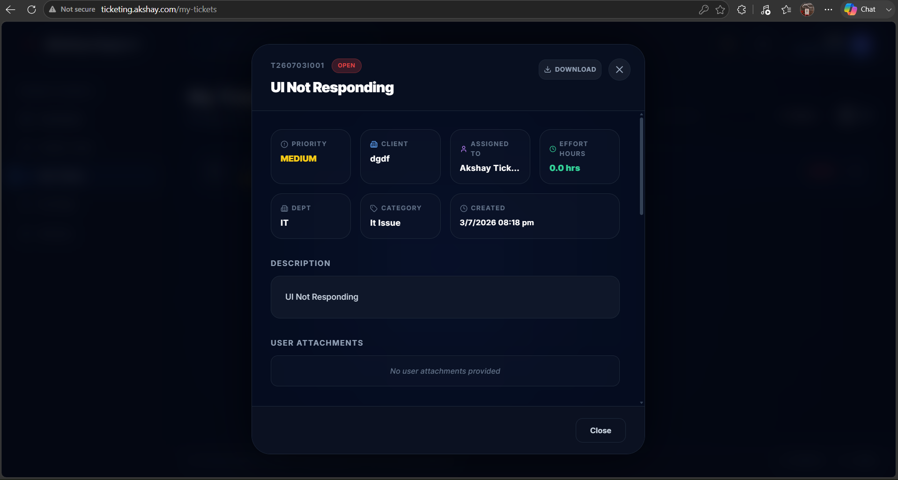
6.1 Ticket Overview
The top section displays essential ticket information.
Typical information includes:
- Ticket ID
- Ticket Title
- Current Status
- Priority
- Department
- Category
- ERP Incident Type (if applicable)
- Created By
- Assigned Consultant
- Created Date
- Last Updated
This information allows you to understand the current state of the ticket at a glance.

6.2 Ticket Summary
The summary section provides a complete description of the reported issue, including:
- Original problem description.
- Business impact.
- Supporting information.
- Reported symptoms.
- Requested assistance.

6.3 Attachments
All files uploaded during ticket creation or subsequent communication are displayed in the Attachments section.
Examples include:
- Screenshots
- Error logs
- Reports
- PDF documents
- Excel files
- Configuration files
Click any attachment to download or view it.

6.4 Assignment History
The Assignment History records every assignment made throughout the ticket lifecycle.
Typical information includes:
- Consultant Name
- Assigned By
- Assignment Date & Time
- Remarks (if applicable)
This provides complete visibility into ticket ownership and routing.

6.5 Activity Timeline
Every action performed on the ticket is recorded in chronological order.
Examples include:
- Ticket Created
- Ticket Assigned
- Status Updated
- Consultant Remarks
- Client Replies
- Attachments Added
- Resolution Submitted
- Ticket Closed
The timeline serves as the complete audit history for the ticket.

6.6 Communication
The Remarks section allows direct communication between the Client User and the assigned Consultant.
To reply:
Step 1
Scroll to the Add Remark section.

Step 2
Enter your message.
Provide any additional information requested by the consultant.

Step 3 (Optional)
Attach supporting files such as:
- Screenshots
- Error logs
- Documents
- Reports

Step 4
Click Submit Remark.
Your message is immediately added to the ticket timeline.
The assigned consultant is automatically notified via email and system notification.

6.7 Best Practices
For faster resolution:
- Respond promptly when additional information is requested.
- Provide complete technical and business details.
- Upload clear screenshots whenever possible.
- Avoid creating duplicate tickets for the same issue.
- Continue communication within the existing ticket instead of sending emails separately.
Maintaining communication within the ticket preserves the complete audit history.

6.8 Ticket Notifications
Whenever activity occurs on your ticket, you may receive notifications for events such as:
- Consultant assignment.
- New consultant remark.
- Status update.
- Additional information request.
- Resolution provided.
- Ticket closure.
Notifications are delivered through:
- In-Application Notifications
- Email Notifications

Expected Outcome
After completing this section, you will be able to:
- View complete ticket information.
- Monitor ticket progress.
- Download attachments.
- Review assignment history.
- Communicate directly with consultants.
- Track every activity performed on your support request from creation through closure.

7. Ticket Statuses Explained
Every ticket follows a predefined lifecycle from creation to closure. Understanding each status helps you know the current progress of your request and whether any action is required from you.

7.1 Ticket Lifecycle
A ticket progresses through different stages based on its current state and consultant activities.
Status | Description | Action Required from Client
Pending | The ticket has been successfully created and is awaiting assignment or processing. | No action required.
Assigned | A consultant has been assigned and will begin reviewing the issue. | No action required. Wait for consultant updates.
In Progress | The assigned consultant is actively investigating or resolving the issue. | Wait for updates or provide additional information if requested.
Hold | The ticket is temporarily paused because additional information, customer confirmation, or external dependencies are required. | Review consultant remarks and respond if requested.
Resolved | The consultant has provided a solution and marked the issue as resolved. | Review the resolution, verify the issue is fixed, and submit feedback.
Closed | The ticket has been successfully completed and officially closed. | No further action required.
Cancelled | The ticket has been cancelled due to duplication, invalid request, or administrative reasons. | Refer to ticket remarks for the cancellation reason.

7.2 Status Notifications
Whenever the ticket status changes, the system automatically generates notifications.
Notifications are sent through:
- In-Application Notifications
- Email Notifications
Examples include:
- Ticket Assigned
- Consultant Reply
- Status Updated
- Resolution Provided
- Ticket Closed

7.3 Understanding the Workflow
The typical ticket lifecycle is:
Pending
│
▼
Assigned
│
▼
In Progress
│
├────────► Hold (if additional information is required)
│ │
│ ▼
│ In Progress
│
▼
Resolved
│
▼
Closed

Expected Outcome
After understanding ticket statuses, you will be able to:
- Track the progress of your support requests.
- Understand the current stage of ticket processing.
- Know when your response is required.
- Monitor ticket completion until closure.

8. Submitting Feedback & Closing Tickets
When the assigned consultant resolves your issue, the ticket status changes to Resolved.
Before the ticket is officially closed, you should review the provided solution and submit your feedback.

8.1 Review the Resolution
Navigate to My Tickets and open the ticket marked Resolved.
Review:
- Resolution Summary
- Consultant Remarks
- Attachments (if any)
Verify that your issue has been resolved successfully.
Figure 9 – Resolution & Feedback Screen
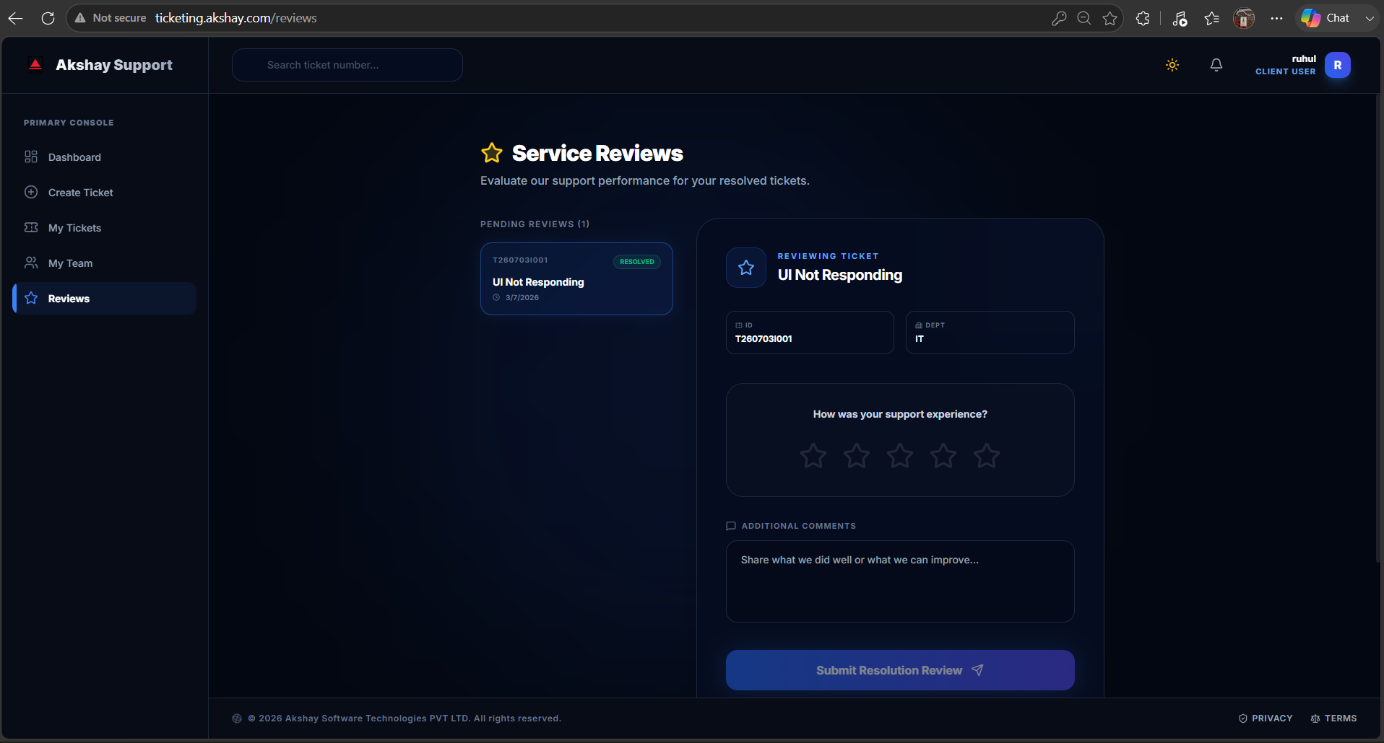
8.2 Rate the Support Experience
If your organization has enabled customer feedback, you can rate the service provided.
Rating | Meaning
⭐ | Poor
⭐⭐ | Below Average
⭐⭐⭐ | Average
⭐⭐⭐⭐ | Good
⭐⭐⭐⭐⭐ | Excellent

8.3 Provide Comments
You may also leave comments regarding:
- Resolution quality
- Consultant professionalism
- Response time
- Suggestions for improvement
Your feedback helps improve service quality.

8.4 Close the Ticket
After verifying the solution:
- Review the consultant's resolution.
- Select your rating.
- Enter optional comments.
- Click Submit Feedback & Close Ticket.
The system will:
- Record your feedback.
- Change the ticket status to Closed.
- Send a confirmation notification.
- Archive the completed ticket.
Note: If the issue occurs again after closure, create a new ticket and reference the original Ticket ID.

Expected Outcome
You will be able to:
- Review consultant resolutions.
- Rate the support experience.
- Provide valuable feedback.
- Officially close completed tickets.

9. Profile & Theme Settings
The Profile & Settings section allows you to manage your personal information, account preferences, appearance, and notification settings.
To access this page:
- Click your Profile Avatar in the upper-right corner.
- Select Settings.
Figure 10 – Profile & Settings
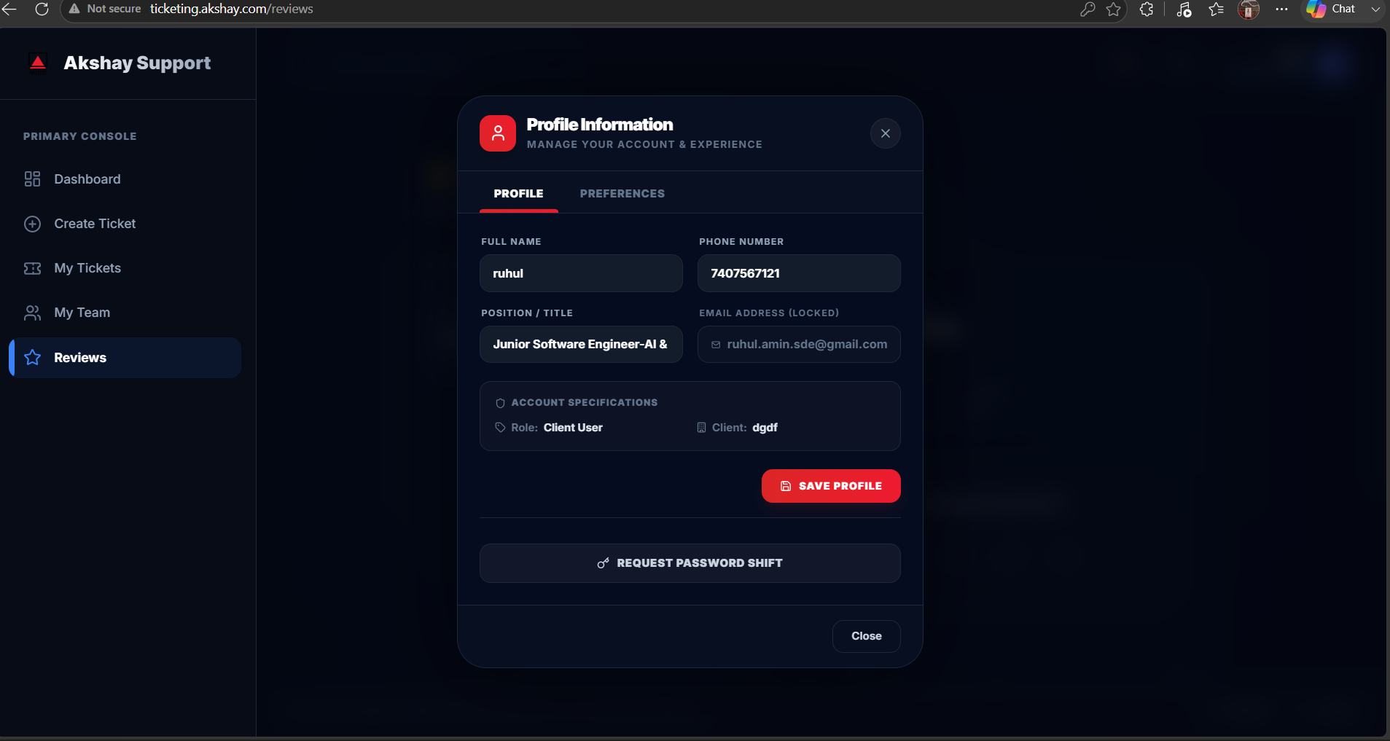
9.1 Profile Information
You can view and manage your personal information.
Typical profile information includes:
Field | Description
Display Name | Your full name displayed throughout the system.
Email Address | Registered login email (may be read-only depending on system configuration).
Mobile Number | Contact number, if enabled.
Company | Organization associated with your account.
Department | Assigned department.
Profile Photo | Upload or update your profile picture (if enabled).

9.2 Theme Settings
The Ticket Management System supports multiple appearance modes for improved usability.
Theme Mode
Mode | Description
Light Mode | Bright interface suitable for daytime use.
Dark Mode | Dark interface designed to reduce eye strain in low-light environments.
System Default | Automatically follows your operating system's appearance settings.

Primary Color
Select the primary application color.
Available options may include:
- Blue
- Indigo
- Purple
- Emerald
- Rose
- Amber
- Cyan
- Orange

Accent Color
Customize buttons, highlights, and interactive elements.

Live Preview
Theme changes are displayed immediately before saving, allowing you to preview the appearance.

Save Changes
After selecting your preferred appearance:
Click Apply Preferences.
Your selections are saved and automatically loaded during future logins.

9.3 Notification Preferences
Manage the notifications you receive.
Notification | Recommended
Ticket Status Updates | Enabled
Consultant Replies | Enabled
Ticket Assignment | Enabled
Resolution Notifications | Enabled
System Announcements | Optional

9.4 Account Security
From the Settings page you can also:
- Change your password.
- Review account information.
- Manage your active preferences.
- Securely log out of the application.

Expected Outcome
After completing this section, you will be able to:
- Update your profile information.
- Customize the application's appearance.
- Manage notification preferences.
- Save personalized settings for future sessions.
- Maintain a more secure and personalized user experience.
10. Email Notifications
The Ticket Management System (TMS) automatically sends email notifications to keep users informed about ticket activities and important system events.
These notifications ensure that all relevant stakeholders remain updated throughout the ticket lifecycle.

10.1 Notification Events
The following system events generate automatic email notifications.
Event | Recipients
Ticket Created | Ticket Creator, Assigned Consultant (if assigned), Configured CC Recipients
Ticket Assigned | Ticket Creator and Assigned Consultant
Ticket Status Updated | Ticket Creator and Assigned Consultant
Consultant Remark Added | Ticket Creator
Client Remark Added | Assigned Consultant
Ticket Resolved | Ticket Creator
Ticket Closed | Ticket Creator
Ticket Cancelled | Ticket Creator
Password Reset | Registered User
Account Created | Newly Created User
System Announcement (if enabled) | Applicable Users

10.2 Email Contents
Each notification typically includes:
- Ticket ID
- Ticket Title
- Current Status
- Summary of the latest activity
- Date and Time of the event
- Direct link to open the ticket
- Organization branding

10.3 If You Do Not Receive Emails
If expected email notifications are not received:
- Check your Spam or Junk folder.
- Add the organization's email address to your trusted contacts.
- Verify your registered email address.
- Confirm that email notifications are enabled in your account settings.
- Contact your System Administrator if the issue continues.

Expected Outcome
After completing this section, you will understand:
- Which activities generate email notifications.
- Who receives each notification.
- What information each email contains.
- How to troubleshoot missing email notifications.

11. Security – Changing Your Password
To maintain account security, it is recommended that you change your password periodically or immediately if you suspect unauthorized access.

11.1 Changing Your Password
To update your password:
Step 1
Click your Profile Avatar.
Select Settings.

Step 2
Open the Security section.
Figure 11 – Change Password
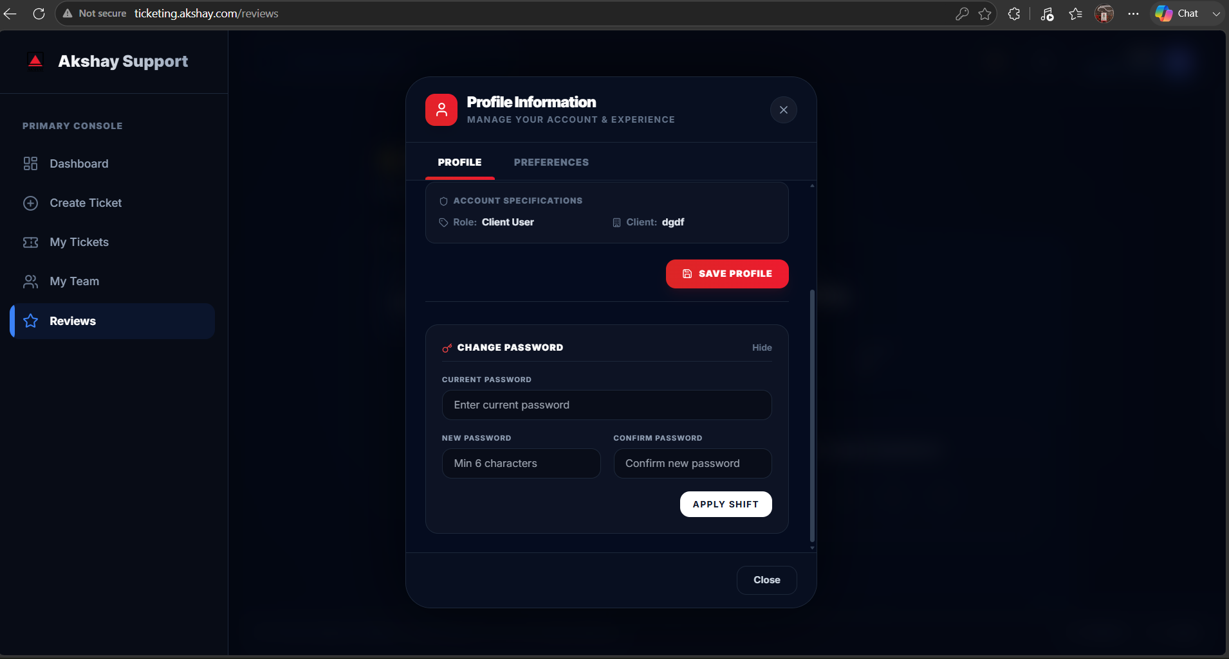)

Step 3
Enter the following information:
- Current Password
- New Password
- Confirm New Password

Step 4
Click Update Password.
If the password satisfies the security policy, the system immediately updates your credentials.

11.2 Password Policy
Your password should contain:
- Minimum 8 characters
- One uppercase letter
- One lowercase letter
- One numeric digit
- One special character (recommended)
A password strength indicator assists you in creating a secure password.

11.3 Password Security Best Practices
For maximum account security:
- Never share your password.
- Use a unique password.
- Avoid dictionary words.
- Change passwords periodically.
- Log out from shared devices.
- Immediately change your password if you suspect unauthorized access.

Expected Outcome
You will be able to:
- Change your password securely.
- Follow organizational password policies.
- Improve the security of your account.

12. Frequently Asked Questions (FAQs)
General Questions
Q1. Why can't I see the ERP Incident Type field?
This field is displayed only when ERP Incident Types have been configured for your organization.

Q2. Can I edit my ticket after submission?
Core ticket information cannot be edited after submission.
However, you can continue communicating with the consultant by adding remarks and attachments.

Q3. Can I reopen a closed ticket?
No.
Closed tickets cannot be reopened.
If the issue occurs again, create a new ticket and reference the previous Ticket ID.

Q4. Why is my ticket on Hold?
A ticket may be placed on Hold because:
- Additional information is required.
- Customer confirmation is pending.
- A third-party dependency exists.
- An external vendor response is awaited.
Review the consultant's remarks for more information.

Q5. How can I identify the assigned consultant?
Open the ticket.
The assigned consultant is displayed in the Ticket Information section.

Q6. Can I change the priority after creating a ticket?
Priority changes require administrative approval.
Contact your consultant or system administrator if the priority needs to be updated.

Q7. Can I upload additional files later?
Yes.
Open the ticket and upload additional documents through the Remarks section.

Q8. My ticket has remained Pending for several hours. What should I do?
Check for recent updates.
If there has been no activity during business hours, contact your administrator or add a remark requesting an update.

Q9. How long does ticket resolution take?
Resolution depends on:
- Business Priority
- Issue Complexity
- Consultant Availability
- External Dependencies
- SLA Agreements

Q10. Can other users from my company view my ticket?
Visibility depends on your organization's access policies and user permissions.
Contact your administrator for organization-specific configurations.

Expected Outcome
This section helps answer the most common questions raised by Client Users, reducing unnecessary support requests.

13. Troubleshooting Guide
The following table lists common issues and recommended solutions.
Problem | Possible Cause | Recommended Solution
Unable to Log In | Incorrect credentials or inactive account | Verify credentials or use Forgot Password.
Dashboard Not Loading | Network issue or scheduled maintenance | Refresh the page and verify your internet connection.
Ticket Cannot Be Submitted | Mandatory fields missing | Complete all required fields before submission.
Attachment Upload Failed | Unsupported format or file size exceeded | Upload a supported file within the permitted size limit.
Missing Email Notifications | Spam filtering or incorrect email settings | Check Spam folder and verify notification settings.
ERP Incident Type Not Available | ERP configuration not enabled | Contact your System Administrator.
Unable to Submit Feedback | Ticket is not yet Resolved | Feedback is available only after the ticket reaches the Resolved status.
Session Expired | Authentication timeout | Log in again to continue working.
Slow Page Performance | Network latency or browser cache | Refresh the browser or clear cached files.
Theme Display Issues | Browser cache conflict | Reload the application or select the preferred theme again.

Need Additional Assistance?
If your issue is not covered in this guide:
- Review the ticket remarks for consultant updates.
- Add additional information to your existing ticket.
- Create a new ticket for unrelated issues.
- Contact your System Administrator for account or access-related problems.

End of Client User Guide

Document Information | Details
Document Name | Client User Guide – Ticket Management System (TMS)
Document Version | v5.0.0.0
Organization | Akshay Software Technologies Private Limited
Prepared By | Ruhul Amin
Reviewed By | Rajan Chelladurai, Reshma Lokhande
Document Status | Approved for Production Use
Classification | Internal – Confidential

